Results-based Management – Community of Practice Initiative

**Results-based Management Case Studies**

1. **Overview**

**Name:** Conserving Nature & People: Creating Compelling Results-based Management Case Studies through Collaboration and Peer-Review

**Brief Description:** A cross-organization peer-review process is proposed to generate compelling stories of results-based management delivering benefits to both nature and human well-being.

1. **Background/Justification**

The survey completed in advance of the May 2010 Measuring Effectiveness Summit[1] clearly conveyed the need for the conservation community to improve results-based management (RBM) practices. Over 70% of NGO’s and 90% of foundations view implementing improved RBM as a high priority yet only a small fraction of projects are currently practicing RBM. For every conservation dollar spent, about a dime is guided by results-based management.[2]

An analysis of the survey results and discussions at the Measuring Effectiveness Summit identified the lack of compelling RBM case studies as one of key obstacles limiting adoption of RBM (Figure 1 on page 2 of this document).

We hypothesize that collaboration among implementing conservation organizations and funders in peer-reviewing and improving results-based management practices for a set of high-profile case studies will lead to influential, powerful stories of why projects should improve their effectiveness measures practices. Widespread marketing of stories from a set of compelling examples will catalyze interest and adoption in applying improved results-based management practices.

We believe that case studies that demonstrate effective RBM for achieving both nature and human well-being benefits will maximize the attention and potential impact of these case studies.

There is emerging evidence that the public generally appreciates the economic value of nature protection. A recent national poll of the American public with a stratified random sample of 800 people) revealed that there is broad appreciation for nature’s economic value (see Box 1 on page 3 of this document).

**Figure 1:** Conceptual Model showing the need for examples of RBM within an overall conceptual model capturing obstacles to practicing Results-based Management

*Box 1: Excerpts from “Communicating with the Public About Nature’s Benefits”*

*Poll Question: Some people say that in making these decisions, we need to recognize that nature provides many benefits for human society. Some of those benefits are direct, such as fish, crops, timber, or ingredients for medicines. Others are less obvious, such as trees that filter pollution out of our air and water; lands that slow or stop floods; and wetlands that reduce the impacts of storm surges created by hurricanes. How important do you think these benefits that nature provides are: extremely important, very important, somewhat important, or not important?* 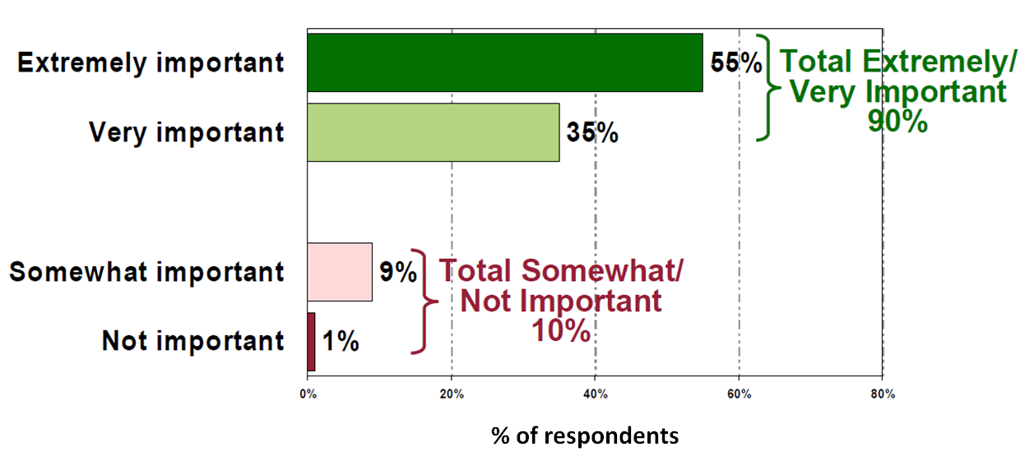

*Poll Question: I’m going to read you a pair of statements. Please tell me which statement you*

*agree with most. Please choose just one, even if neither fits your opinion exactly.*

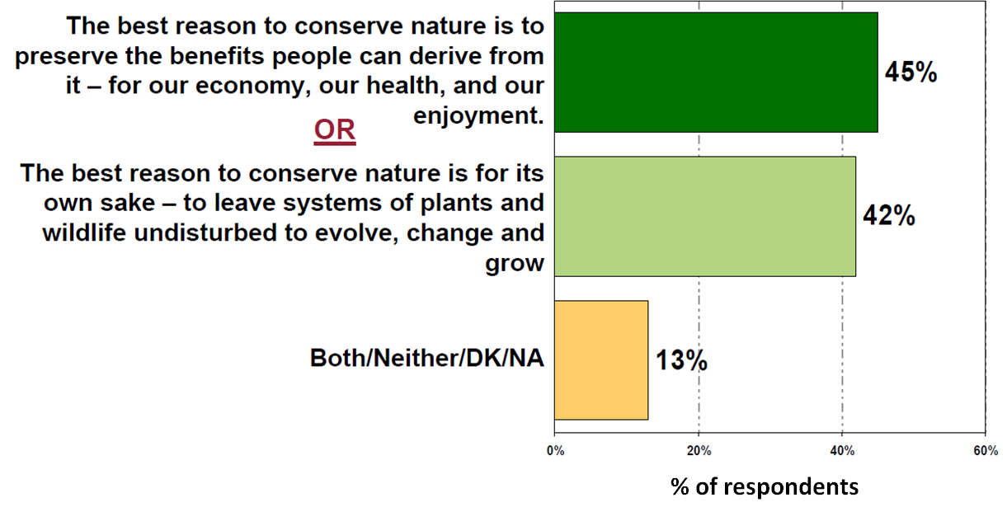

*Nature Conservancy poll, FM3 and Public Opinion Strategies, 2010*

<http://massland.org/files/TNC_Summary_Language_Memo.pdf>

The results in Box 1 demonstrate that although the motivation of people for conserving nature is mixed, nearly all agree on the importance and priority. The challenge to conservation is to offer more compelling evidence that conservation projects actually deliver these benefits to people.

This initiative includes 3 approaches for creating RBM case studies that address nature and human well-being conservation:

1. Six case study examples from a Moore Foundation grant awarded to Resources for the Future (RFF) and The Nature Conservancy to study Conservation Return on Investment.
2. An interview-based approach to harvest lessons learned from past or ongoing projects.
3. A peer-review process to strengthen a set of proposed or recently implemented projects.
4. **Case Studies from the Moore Foundation funded project on “Conservation Return on Investment”**

This is a two-year research project being conducted by RFF and TNC with funding by the Moore Foundation that was awarded in the fall 2010. This research will evaluate the state of RBM practices using a return on investment analysis for 6 TNC projects (2 in the United States, 1 from Canada, 2 from South America, and 1 from Asia Pacific).

1. **Interview-based approach**

Case studies involving nature and people will be drawn from two broader case study projects recently launched by WWF and TNC.

**WWF:** Sheila O’Connor is working with contractor Deborah Heaney to develop case study stories from projects that have been applying the *Open Standards for the Practice of Conservation*. Case study summaries will include lessoned learned (both things that worked and things that did not work from a large number of projects) and include some case studies that provide clear evidence of the “impacts” from applying the *Open Standards.* Candidate projects will be drawn from the WWF network and from other organizations that are part of the Conservation Coaches Network[3]

**TNC:** Susan Moffat is serving as a Coda Global Fellow [4] to develop case studies summaries drawn from projects featured on the Conservation Gateway ([www.conservationgateway.org](http://www.conservationgateway.org)). She will be conducting phone, email, or potentially face-to-face interviews with TNC project teams and producing downloadable case study descriptions for a subset of projects that include an explicit focus on conserving biodiversity and human well-being values.

1. **Peer-review process**

We propose using a formal peer review process to review and improve project plans from several organizations to help build a set of compelling case study examples. The peer review will include some of the projects featured in the Moore funded research and the interview-based approach described above as well as additional projects submitted by CMP organizations. To minimize costs, the peer review process will take place virtually through a combination of live web-based presentations, written peer review, and web-based discussion and feedback sessions. See the Proposed Activity table below for an outline of the proposed peer review process.

It may take several years before the results from these peer-reviewed case studies generate truly compelling stories in terms of biodiversity and human well-being outcomes. However, even interim results will be effective if they are supported with solid action and measuring effectiveness plans, establishment of baseline measurements, and implementation of a transparent, regular reporting process to share intermediate results. Some of the case study projects included in this initiative will be candidates to serve as “bright spots” in the 2011 Measuring Effectiveness Summit. We hope to publicize the case studies through public media outlets, publications, and websites.

1. **Key Expected Outcomes**

**Short term outcome (by December 2011):** 3-5 compelling case studies demonstrating effective results-based management approaches for conserving nature and people.

**Longer term outcome:** Adoption of results-based management practices showing nature conservation and human well-being results on 100’s of projects based on communication and marketing of case studies.

1. **Proposed Team and Activities**

Team Members:

* Dan Salzer, The Nature Conservancy
* Jensen Montambault, The Nature Conservancy
* Sheila O’Connor, WWF
* Jim Boyd, Resources for the Future
* Ruth Bowman, Margaret A. Cargill Philanthropies
* Carter Ingram, Wildlife Conservation Society
* Hari Balasubramanian, Conservation International

**Interview-Based Case Study Component**

|  |  |  |
| --- | --- | --- |
| **Key Actions** | **Completed by** | **Who’s Responsible** |
| **WWF:** Get details from Sheila |  |  |
| **TNC:** Get details from Susan and Jensen |  |  |

**Peer-Review Component**

| **Key Actions** | **Completed by** | **Who’s Responsible** |
| --- | --- | --- |
| Circulate revised initiative description to the original RBM Case Study Group and the Measuring Effectiveness Summit organizing committee | August 19, 2011 | Dan Salzer |
| 2-3 conference calls to review potential case study projects and discuss the peer review protocol. | October 30, 2011 | RBM Case Study Group |
| In-person meeting at the CMP/Funders Summit II to plan the peer-review process, review candidate CPN projects, nominate others and select an initial set to start with | November 16-17, 2011 | RBM Case Study Group |
| Series of WebEx conferences where project teams deliver presentations introducing their project and distributing project plans to review | February 2012 | RBM Case Study Group |
| Written peer-review comments delivered to project leads. Each project team will peer-review 2(?) other project plans. | March-April 2012 | RBM Case Study Group |
| WebEx conferences to discuss written peer review feedback. Question/answer sessions between reviewers and project staff. | March-April 2012 | RBM Case Study Group |
| Outreach and communications efforts | May-June 2012 | RBM Case Study Group |

1. **Timeline and Budget**

Timeline

See Key Actions Table

Budget

No additional resources needed prior the November 2011 Summit. Post-Summit, funding will need to be secured to cover case study marketing and communication costs.

1. **Monitoring and Evaluation and Communications Plan**

Draft set of monitoring indicators

* Number of completed case studies that meet specific criteria for results-based management
* Number of media stories featuring the case studies
* Number of hits on case study website
* Number of times case studies are referenced in other project plans and publications

Communications Plan

Key Audiences:

* Senior managers in implementing organizations and funding organizations
* Donors
* Practitioners

Outreach mechanisms:

* Public media outlets
* Publications
* Websites

1. <http://www.conservationmeasures.org/measures-summit>
2. Muir, MJ (Draft 2010) Are we measuring conservation effectiveness? A survey of current results-based management practices in the conservation community.

   <http://www.conservationmeasures.org/wp-content/uploads/2010/09/Survey-Report-Draft-2010-06-06_v3.docx>
3. Conservation Coaches Network (<http://www.conservationgateway.org/file/conservation-coaches-network-fact-sheet>)
4. Coda Global Fellows for Measures (<http://www.conservationgateway.org/content/coda-global-fellows-measures>)