2a-2. Instructions for Breakout Session on
Results Chain Development

Purpose of the Exercise
The purpose of this exercise is to build results chains for your project strategies. Results chains help you to make your assumptions explicit about how conservation interventions contribute to the reduction of priority threats and support the conservation of targets. To develop the results chains, you will need your list of selected strategies and the threats they are intended to reduce and conservation targets they will help conserve.

Definitions
- Results Chain – A diagram with a series of “if…then” statements that define how you think that a project strategy is going to contribute to achieving a conservation goal. The results chain focuses on the achievement of results – not the implementation of activities – and it is composed of assumptions that can be tested. A good results chain meets the following criteria:
    - results oriented,
    - causally linked,
    - demonstrates change,
    - reasonably complete, and
    - simple.

Example
  - Scope of the Project – Wetlands and bordering habitat on Swan Coastal Plain
  - Vision – Long-term conservation of high value wetlands and adjacent habitats on the Swan Coastal Plain so that they persevere as rich and viable biodiversity habitats for all wildlife, and for the benefit and appreciation of future generations.
  - Goal – By June 2020, 300 new private properties encompassing 150 ha of high conservation value* wetlands on the Swan Coastal Plain reliably support key ecological processes** and contain viable populations of key native flora and fauna, as listed by the Department of Environment and Conservation.
* High conservation value wetlands = wetlands assigned ‘Conservation’ management category by the Department of Environment and Conservation, Western Australia.
** Ecological processes include groundwater recharge and hydroperiod (see viability assessment)
    - Strategy – Promote best management practices (BMPs) and conservation protection mechanisms
    - Results Chain:
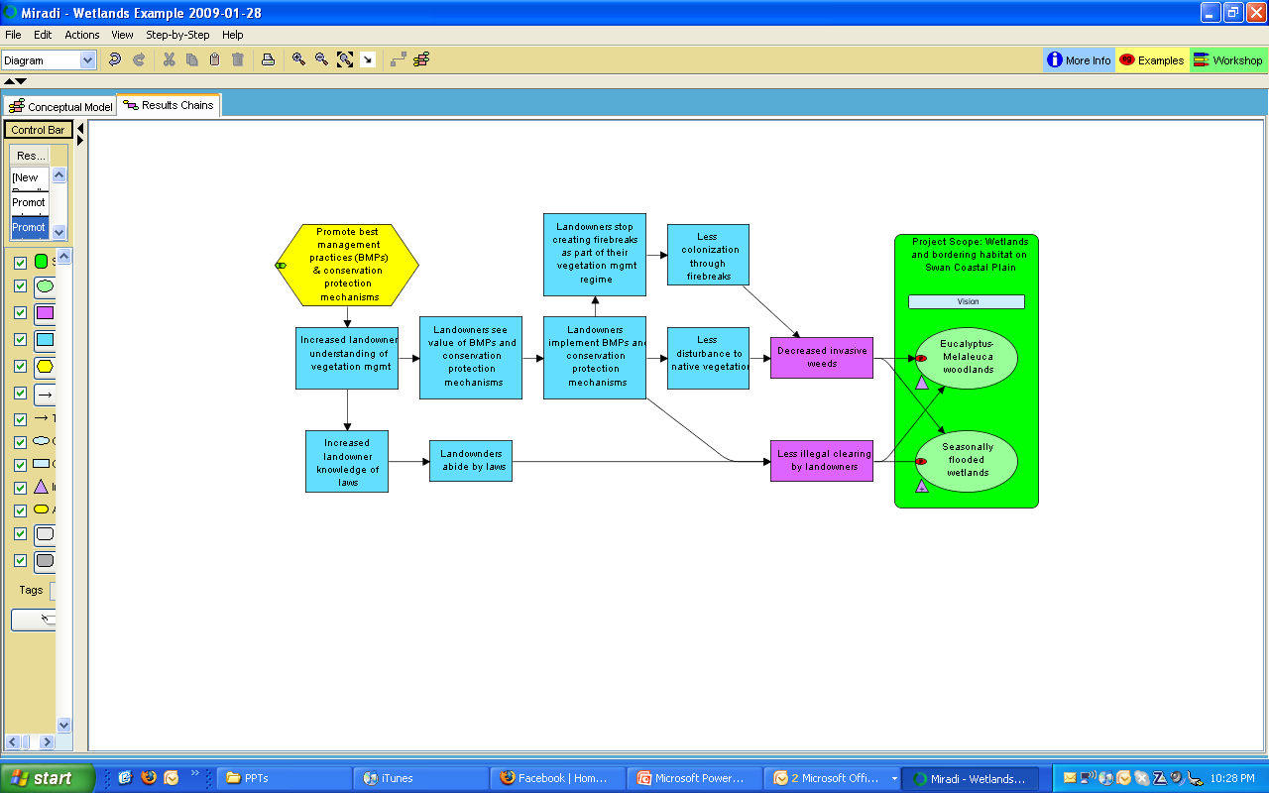

Procedure

1) Begin to build a results chain for one of your selected strategies, using Miradi. Select a strategy, right-click and select “create results chain.” Then transfer all of the factors that appear on your initial results chain (strategy, intermediate results, direct threat and target(s)) onto a sticky tarp or flip-chart paper. You will continue your work on the sticky tarp or flip chart paper.
2) Build the intermediate part of the chain. You can build from the right to the left, defining what has to happen to diminish the threat, and what is needed so that can happen, etc. You can also build from the left to the right, defining the desired short-term results of the actions, then defining the medium-term results, until arriving at the reduction of the threat. Another option is to brainstorm intermediate results and then connect them and fill in gaps. FOS generally recommends building results chains from right to left.
3) Ensure that the chain meets the criteria of a good results chain.
4) Transfer the results chain to Miradi.
5) Repeat steps to complete a second results chain (unless the first one was very complex).

