CMP - CCNet Adaptive Management Case Study Template
Case Study Title: Using an Adaptive Management approach to expand efforts to save cotton-top tamarins in Northwest Colombia.
Authors: Rosamira Guillén, Johanna Vega: Fundación Proyecto Tití. Armando Valdés-Velásquez: Independent Consultant with Foundation of Success
Contact Person: Johanna Vega, jvega@proyectotiti.com
Location: Departments of Atlántico and Bolívar in Northwest Colombia (Tropical Dry Forests remnants)
Summary: Proyecto Tití has worked for the last 30 years to secure a long term future for the critically endangered cotton-top tamarin (Saguinus oedipus), a small primate endemic to northern Colombia, using an integrated conservation approach. For many years, and due to social and political instability, Proyecto Tití’s work was restricted to the northernmost area of its distribution; but with a peace process under implementation, led by Colombia’s national government, new opportunities arose to expand our conservation work into new areas and thus increase the impact of our efforts on behalf of cotton-tops and their forest home. We worked with Foundations of Success to design an strategic plan with its corresponding operational and action plans, using the Open Standards and an Adaptive Management (AM) approach to make informed decisions to overcome some of the challenges that we faced in implementing our strategies and to take advantage of the opportunities, especially the opportunity to double the impact of our work by expanding our conservation work to a new site.
Public Overview of Case Study: Strategic planning process: https://www.miradishare.org/projectDetails/disney-waltdisney-2016-00016/
For more information about Proyecto Titi please visit: www.proyectotiti.com
Setting the Scene: The cotton-top tamarin (Saguinus oedipus) is a critically endangered primate endemic to the tropical dry forests of northwest Colombia (Mast et al, 1993). The species was declared endangered in 1973 after 20,000 to 30,000 cotton-top tamarins were exported from Colombia for biomedical research during the 1960's and 70's (Hernandez Camacho & Cooper, 1976). Today, their existence within Colombia is still threatened, mainly by extensive habitat destruction and extraction of individuals for the illegal pet trade (Miller et al, 2004). Furthermore, results from a 2006-2007 population census showed a dramatic decline in the populations, with less than 7,000 animals remaining in the wild (Savage et al, 2010). These results prompted the IUCN and the Colombian environmental authorities to reclassify cotton-top tamarins as Critically Endangered (Savage et al, 2009a).
Proyecto Tití was founded in 1985 as a field conservation project, focused on protecting cotton-top tamarins in the wild. In 2004 Fundación Proyecto Tití (FPT) was created as the Colombian non-profit organization to lead conservation efforts on behalf of this endemic primate and its forest home. FPT has made significant advances in understanding the biology and ecology of this primate. Moreover, FPT has always been committed to working with local communities through the development of effective conservation education programs and community empowerment initiatives that provide rural communities with the capacities required to promote the conservation of cotton-top tamarins in Colombia (Savage et al, 2009b). Before starting our strategic planning process in 2013, our conservation work focused on a 400+ hectare forest fragment in Santa Catalina (Bolívar) and its surrounding communities, limited by political instability of other target areas. However, this area has had its share of challenges. For example, we managed to stop an airport project by stirring the government to declare this remaining area of forest a protected area in benefit of the whole region. As political conditions changed positively, we saw the need to increase the impact of our conservation work to other regions. As a result, we decided to use the Open Standards to plan our growth and expansion to San Juan Nepomuceno, enhancing the scope of our work to include, in the following years, the two departments, Atlántico and Bolívar. Both contain some of the most critical forest remnants for cotton-top tamarins, where we run our programs including field research, forest protection, community empowerment and environmental education. To our understanding, the Open Standards is one of the methods best-suited for conservation planning, mainly because the types of indicators required to measure success in conservation and the timing of measurements are entirely different than in regular planning processes. Furthermore, the methodology promotes adaptive management, which in conservation is very important considering that many external factors influence and affect the implementation of strategies. For our strategic planning, we defined a window of 5 years, from 2014 to 2018, and established goals, objectives and indicators accordingly. We implemented the planning sessions during six months in 2013 and then worked out required funding and logistics for another six months. We were fortunate to have a FOS coach throughout the planning process, in which we also learned how to use the Miradi Software as a support tool for our planning.
As a result of the strategic planning process, we defined eight strategies to reduce the identified threats to the cotton-top tamarin and its forest habitat (Fig. 1). Our shared vision incorporated an integrated approach to cotton-top tamarin conservation, and hence, conditioned the identification of strategies to reduce its threats. We defined a variety of threats, though we were conscious that we would not be able to affect, stop, or mitigate all of them. We decided to work on four threats within our scope that we could genuinely change based on our institutional capacities, including both human and financial resources. Implementation started in January 2014 and we conducted follow-up meetings every six months and Adaptive Management (AM) sessions once a year. The idea behind these events was to adjust our strategies to changes in the context or due to information collected in that period. We carried out the last AM session for this period in March 2018. In that session, we decided to close this term, discussing what we had learned in the past five years and using these lessons to adapt our plan for the next five years.
Results and Lessons Learned: Here we share some of the results and lessons learned that arose from our yearly AM sessions. During these sessions, we reviewed information, discussed the interpretation of what we measured, contrasted scenarios and finally made decisions regarding the next year of operations. We hereby present specific results from two such sessions, and then some general lessons learned. For example, in the 2015 AM yearly session, we decided to abandon one of our strategies: Strategy 1 (Fig. 1). We explored all the possibilities concerning the implementation of a restoration and reforestation program in the Santa Catalina area, and tested different approaches as suggested on our results chain, with the support of the regional environmental authorities and other stakeholders in the area. However, the landowners surrounding the protected areas in the region, were not interested in any kind of agreement or initiative to preserve the buffer area around the forest remnants within the boundaries of their cattle ranches. Confronted with this challenging situation and the negative data we had collected on local landowner perception of potential benefits to more conservation-friendly activities, we decided to abandon Strategy 1. At that moment we assessed the opportunity to implement a similar restoration and reforestation program in San Juan Nepomuceno (Bolívar), that we named Strategy 9 (Fig. 2). The land tenure situation in this new area was more suitable to agreements, as people living in this area were owners of small farms. They showed interest in protecting the forest buffer area by building corridors in their properties to connect adjacent forest patches.
Then in the 2016 AM session (the following year), we adjusted the scope of the human populations we were working with as part of our Strategy 3 (Fig.2). Since most of the target communities of our conservation work had access to natural gas, and thus were not solely depending on firewood for their daily cooking, we decided to limit our work with two communities that still did not have access to natural gas. We also documented that for future plans, we would need to discuss considering charcoal production (for urban restaurants) as a stronger threat for forest conservation than firewood, based our own observations and testimonials from local communities. Charcoal production required a different kind of approach and thus, a different strategy. That same year we also created a new strategy, Strategy 10 (Fig.2), to account for all of the administrative, fundraising, human resources and operational efforts to keep our programs running and our team safe and healthy. We realized that these efforts should be integrated into our strategic plan, considering the amount of financial and human resources needed to keep our operations running efficiently. One of the outcomes of this change was the creation of a detailed timeline (Fig.3) as an additional tool for follow-up activities and monitoring. In this way, it became more efficient visually to analyse times and efforts required to carry out the activities. The sum of these adjustments shows how our six-month reviews and yearly AM sessions made it possible for the FPT team to redefine scope, correct tools, rethink indicators and merge strategies when needed. We also have gathered a set of lessons learned and successes as results of this process. We realized the importance of setting measurable indicators that show how threats have been affected, either reduced or stopped in their increasing trend, as a consequence of the activities programmed in the different results chains. Apparently, this is something obvious to do. Still it is imperative to find the right threat reduction indicator, otherwise, it would be hard to show how particular conservation actions affect the threats and help conserve or maintain the targets. Another significant result, specifically of the last AM session (2018), is the plan for the next five years. We are still adapting the entire scheme but we have confidence in getting more significant results in the following period because we are far into the path of mastering the approach, the processes and the tools.
Finally, we have learned that the entire Strategic Planning process and especially the AM approach, requires commitment and resources, particularly time. There is a significant investment of time in getting to a point where the process is second nature to the team, but a by-product of the process itself is how it encourages the team to stay focused and to keep track of their progress towards goals. This process taught us the importance of the team’s involvement in all steps of the planning process, especially those members of the team on the ground, who can provide very valuable feedback in the evaluation of the effectiveness of each strategy. At the same time, this process allowed to adjust for external threats and to take advantage of the opportunities that arise as it helps to identify potential new partners and to leverage funds by being able to show a robust strategic plan that has measurable results. We believe as a team, after this long process, that doing good AM is a matter of becoming more strategic in which opportunities to choose and how to answer to challenges.
Application beyond Case: We have strengthened some strategies that we can currently replicate to other forest remnants in the historical distribution of our focal species. In the last AM session (March 2018), we decided to explore the potential benefits and risks of expanding our efforts and actions to a third area for the next five-year period. We have decided to devote one year to this exploration process, as it requires knowledge about the context of the potential new place, as well as examination of potential funding to expand our efforts. We need sufficient information to make sound decisions, and we need time to collect this information. We do not forget that we are a community-based conservation program and active participation is one of our core values. That is why we involve every team member and critical stakeholder in the strategic planning process, allowing us to modify the strategies in a way that makes them more efficient and gather data on the ground to improve our decision-making processes. We are aware that AM is a continuous and cycling process, and we hope to be able to discuss intelligently, the expansion of our scope of action as well as our conservation efforts in the next AM session in 2019.
Further Information: Context prior to the strategic planning process: https://www.youtube.com/watch?v=iwhhAZbIbUk
-Executive Director, Rosamira Guillen introducing FPT’s current work at WCN Fall Expo 2017: https://www.youtube.com/watch?v=O2Qz6TmfD-o
-Testimonials and Figures : https://docs.google.com/document/d/1pC1H-4NrwWZSE3tFR0sCdKORj0tIojRn86DKwy5-AaA/edit?usp=sharing
Anex Figures:

Figure 1:Proposal of Strategic Planning session 2014  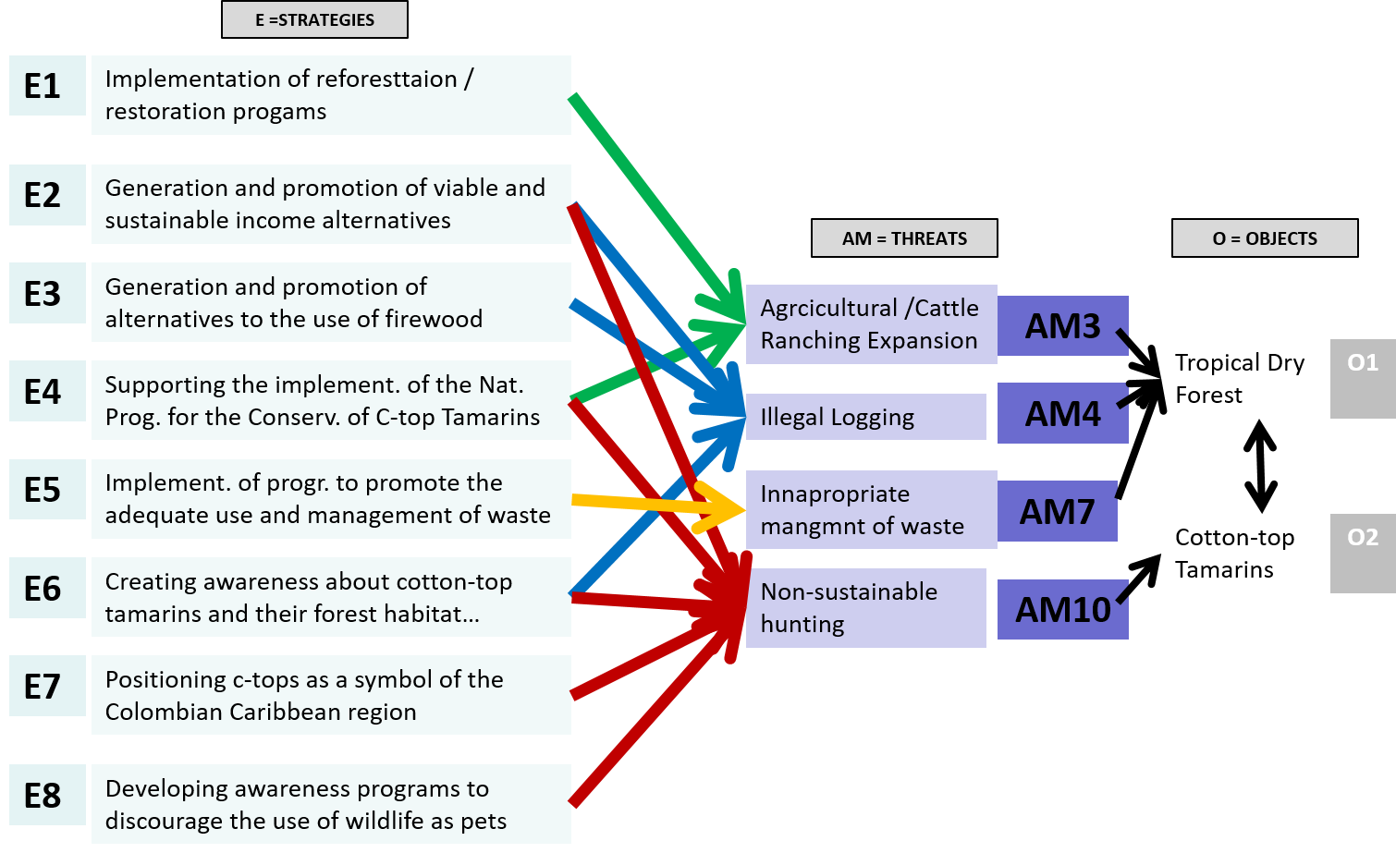 | Figure 2: Result of 2015 and 2016 AM sessions  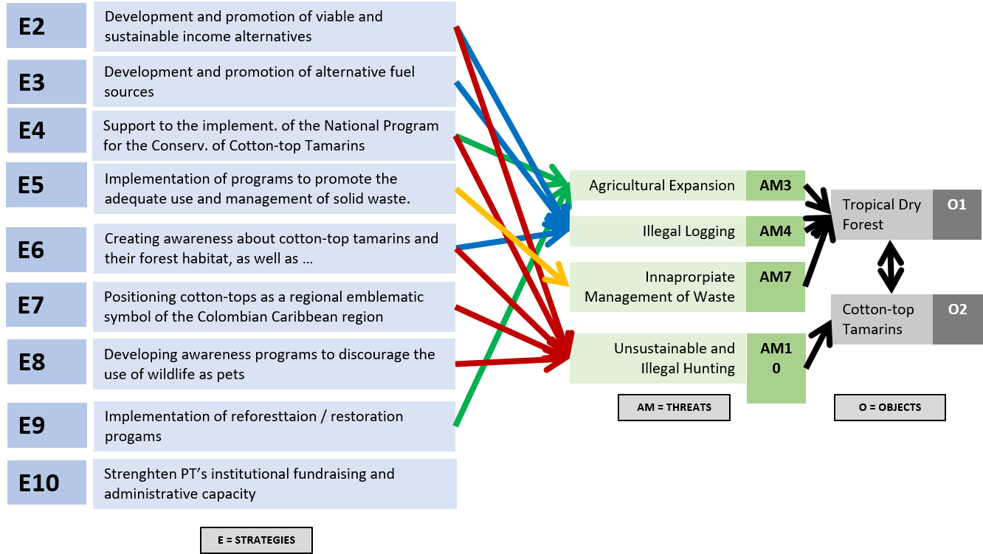 | Figure 3: Detailed timeline and monitoring for programmatic work:  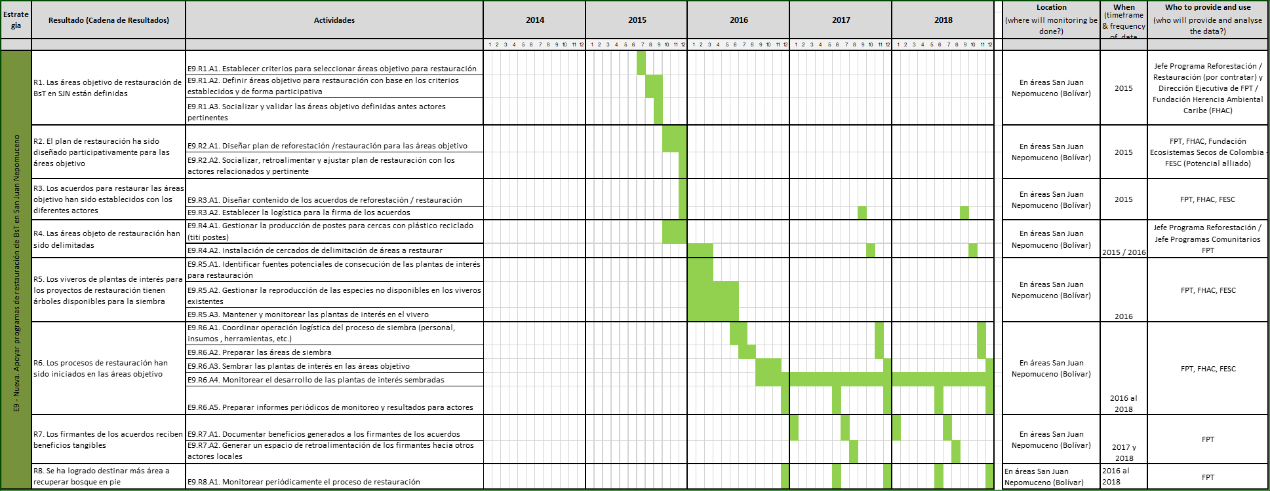

Key Words:
Table of Key Words for Tagging Case Studies
These tags will be used to help other people find your case study on the web.
Key Words (select all that are relevant) | Put x if Relevant
Stages in Adaptive Management Cycle
- Conceptualize the situation
- Plan actions and monitoring | X
- Implement actions and monitoring
- Analyze, use, adapt | X
- Capture and share learning | X
- Full cycle adaptive management | X
- Other__________________________
Case Study Scale
- Project-level
- Program-level | X
- Organizational-level | X
- Other _________________________
Specific Tools/Approach Used
- Evaluation / audit | X
- Evidence-based conservation | X
- Spatial conservation planning
- Structured decision making | X
- Status measures
- Effectiveness measures | X
- Passive adaptive management
- Active adaptive management | X
- Other _________________________
Specific Topics Addressed:
- Human wellbeing
- Climate change
- Community-based conservation | X
- Marine conservation
- Freshwater conservation
- Terrestrial conservation | X
- Other: species focused conservation | X

**REFERENCES
1) MAST RB, RODRIGUEZ JV, MITTERMEIER RA. The Colombian cotton-top tamarin in the wild. En: Clapp NK, editor. A primate model for the study of colitis and colonic carcinoma: The cotton top tamarin: Saguinus oedipus: Boca Raton, FL: CRC Press; 1993. p. 3-43.
2) HERNANDEZ-CAMACHO, J. & COOPER, R.W. The nonhuman primates of Colombia. In Neotropical Primates: Field Studies and Conservation: 35-69. Thorington, R. & Heltne, P.G. (Eds). Washington, DC: National Academy of Sciences. 1976.
3)MILLER L, SAVAGE A, GIRALDO H. Quantifying the remaining forested habitat within the historic distribution of the cotton-top tamarin (Saguinus oedipus) in Colombia: Implications for long-term conservation. Am J Primat. 2004; 64:451.
4)SAVAGE, A., THOMAS, L., LEIGHTY, K., SOTO, L., MEDINA, F. Primates on the brink: Novel survey method finds dramatic decline of wild cotton-top tamarin population. Nature Communications 1:30 DOI:10.1038/ncomms1030, 2010.
5) SAVAGE, A., SOTO, L., LAMILLA, I. AND GUILLEN, R.. Cotton-top tamarin Saguinus oedipus (Linnaeus, 1758). In: R. A. Mittermeier et al., Primates in Peril: The World’s 25 Most Endangered Primates 2008–2010, pp.68-71. IUCN/SSC Primate Specialist Group (PSG), International Primatological Society (IPS), and Conservation International (CI), Arlington, VA. 2009a.
6) SAVAGE, A.,GUILLEN, R., LAMILLA, I., SOTO, L. Developing an Effective Conservation Program for Cotton-top Tamarins (Saguinus oedipus) in Colombia that Incorporates Strategies Addressing Integrated Conservation and Community Development Initiatives. American Journal of Primatology, 2009b, 71:1-12.

